1. 
2. 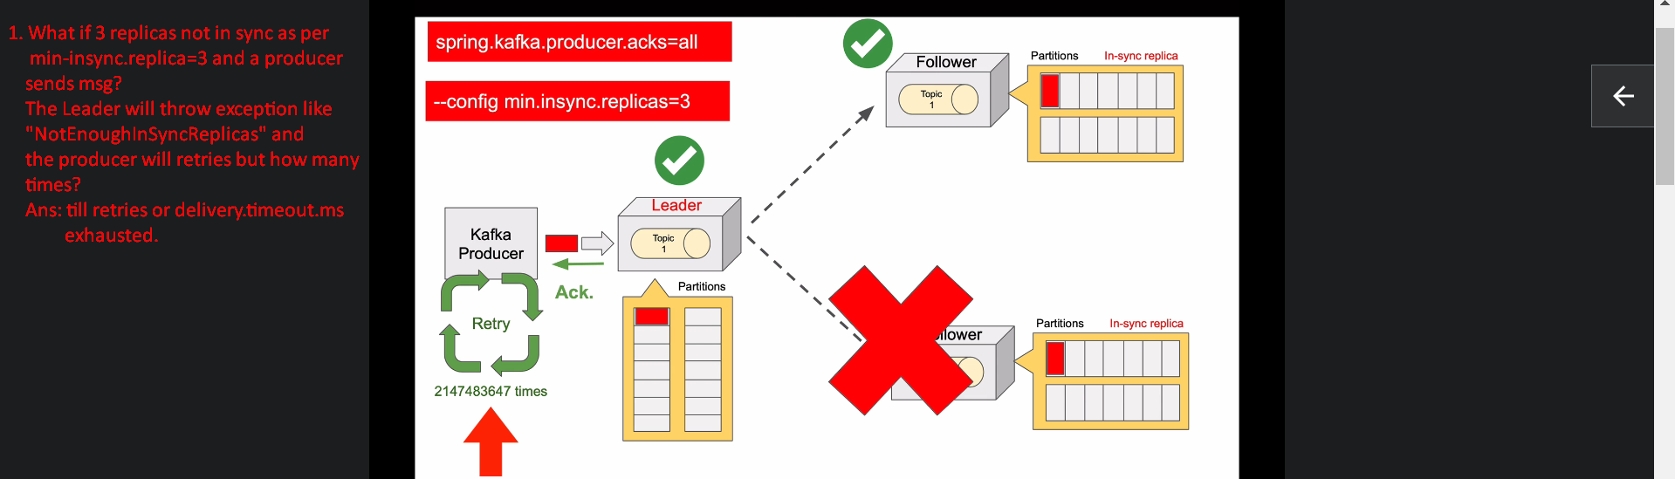
3. 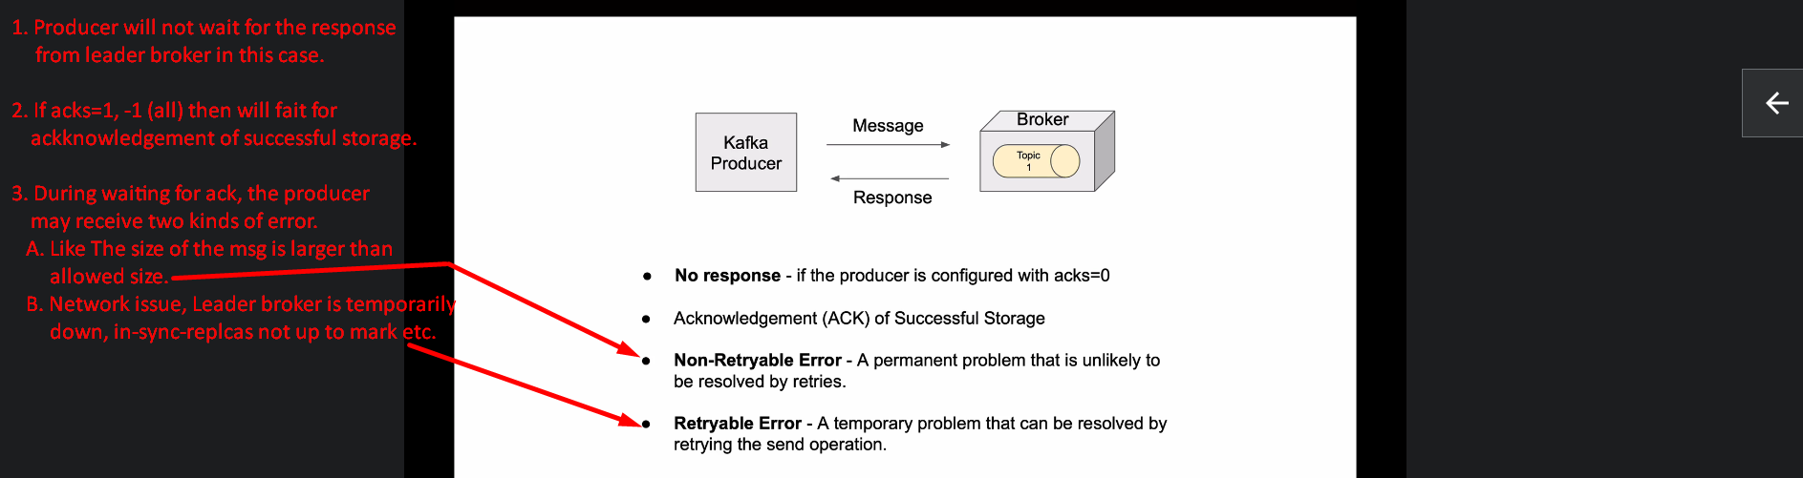
4. Through configuration properties, we can control the behavior of producer retry.
5. Spring.kafka.producer.retries=10: The default value is vey large which means that the producer will retry indefinitely until the msg is delivered or delivery.timeout.ms is done. 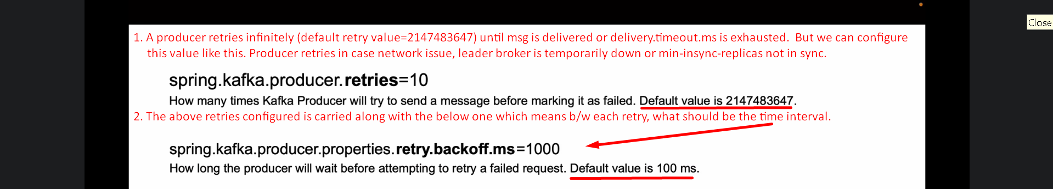
6. 